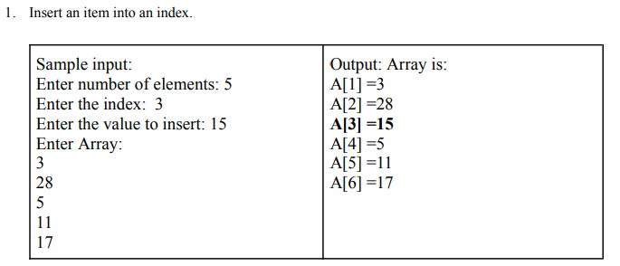

#include<stdio.h>

void main(){

int i, num,pos,size;

printf("Enter number of elements :");

scanf("%d", &size);

int array[size+1];

for(i=1; i<=size; i++)

{printf("Enter the %d element:\n",i);

scanf("%d",&array[i]);}

printf("Enter the number you want to insert in the array");

scanf("%d", &num);

printf("Enter the position of the element");

scanf("%d", &pos);

for(i=size; i>=pos; i--){

array[i+1]=array[i];}

array[pos]=num;

size++;

for(i=1; i<=size; i++){

printf("A[%d]=%d\n",i,array[i]);}}

**Output:**

Enter number of elements :5

Enter the 1 element: 3

Enter the 2 element: 28

Enter the 3 element: 5

Enter the 4 element: 11

Enter the 5 element: 17

Enter the number you want to insert in the array 15

Enter the position of the element 3

**1**

A[1]=3

A[2]=28

A[3]=15

A[4]=5

A[5]=11

A[6]=17

Process returned 6 (0x6) execution time : 44.508 s

Press any key to continue.

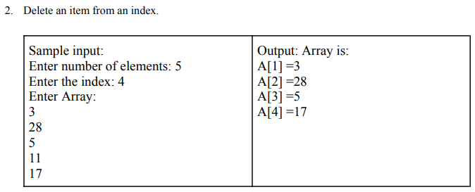

#include<stdio.h>

void main(){

int index, i, size;

printf("Enter number of elements: ");

scanf("%d",&size);

int a[size+1];

for ( i = 1; i <=size; i++)

{printf("Enter the %d element :",i);

scanf("%d",&a[i]); }

printf("Enter the index you want to delete :");

scanf("%d",&index);

if (index<size)

{ for ( i = index; i <= size; i++)

{a[i]=a[i+1]; }

size--;

for ( i = 1; i <= size; i++)

{printf("A[%d]=%d\n",i,a[i]); }}}

**Output:**

Enter number of elements: 5

Enter the 1 element :3

**2**

Enter the 2 element :28

Enter the 3 element :5

Enter the 4 element :11

Enter the 5 element :17

Enter the index you want to delete :4

A[1]=3

A[2]=28

A[3]=5

A[4]=17

Process returned 4 (0x4) execution time : 31.982 s

Press any key to continue.

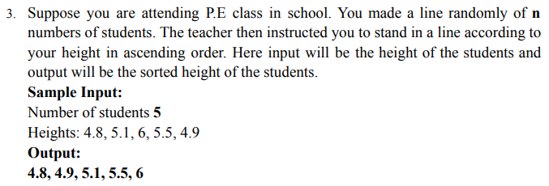

#include <stdio.h>

void main()

{ int i, j, num;

float array[100];

printf("Enter the number of elements for the array:\n");

scanf("%d", &num);

for (i = 0; i < num; i++)

{ printf("Enter the element for index %d:\n", i + 1);

scanf("%f", &array[i]); }

for (i = 0; i < num - 1; i++)

{for (j = 0; j < num - i - 1; j++)

{if (array[j] > array[j + 1])

{float temp = array[j];

array[j] = array[j + 1];

array[j + 1] = temp; } } }

printf("Output: Sorted Array is:\n");

for (i = 0; i < num; i++)

{printf("A[%d] = %.1f\n", i + 1, array[i]); }}

**3**

**Output**:

Enter the number of elements for the array: 5

Enter the element for index 1: 4.8

Enter the element for index 2: 5.1

Enter the element for index 3: 6

Enter the element for index 4: 5.5

Enter the element for index 5: 4.9

Output: Sorted Array is: A[1] = 4.8

A[2] = 4.9

A[3] = 5.1

A[4] = 5.5

A[5] = 6.0

Process returned 5 (0x5) execution time : 15.725 s

Press any key to continue.

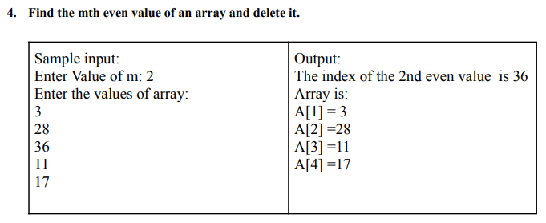

#include <stdio.h>

void main() {

int i, n, element, j, b = 1;

int array[100];

printf("Enter the number of elements for array:\n");

scanf("%d", &n);

for (i = 1; i <= n; i++) {

printf("Enter the element for %dth index:\n", i);

scanf("%d", &array[i]); }

for (i = 1; i <= n; i++) {

if (array[i] % 2 == 0) {

if (b == 2) {

for (j = i; j < n; j++) {

array[j] = array[j + 1]; }

n--; } else { b++; }}}

**4**

for (i = 1; i <= n; i++) {

printf("A[%d]=%d\n", i, array[i]); }}

**Output:**

Enter the number of elements in the array: 5

Enter the value of m: 2

Enter the values of the array:

3

28

36

11

17

The index of the 2th even value is 36

Array is:

A[1] = 3

A[2] = 28

A[3] = 11

A[4] = 17

Process returned 0 (0x0) execution time : 22.993 s

Press any key to continue.

**5**